Installing SQL Server Developer Edition

* Click link to go to Downloads page

<https://www.microsoft.com/en-us/sql-server/sql-server-downloads>

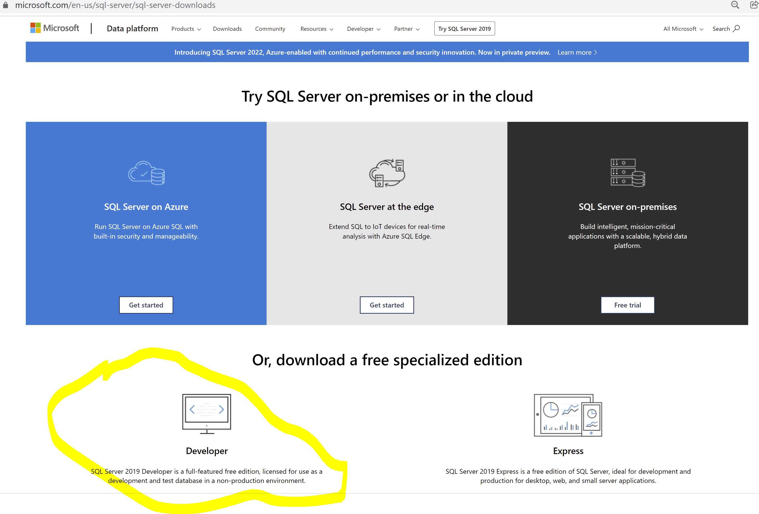

* Choose Developer Edition and click **Download Now**
* Once down, check your Download folders for the **SQL2022-SSEI-Dev** file.
* Double click on the file and installation will begin.

* Choose Basic installation type
* Read the entire license terms then click Accept

* A screenshot of a software update

  Description automatically generated
* Click Install
* A screenshot of a computer program

  Description automatically generated
* When done, you should see the following screen
* A screenshot of a computer program

  Description automatically generated
* Click on Install SSMS
* A screenshot of a computer error

  Description automatically generated
* It will download software. Run the software and take all the default settings

Go to the Start Menu.

* Server name is the name of your PC. If you installed correctly you should see this screen
* A screenshot of a computer

  Description automatically generated